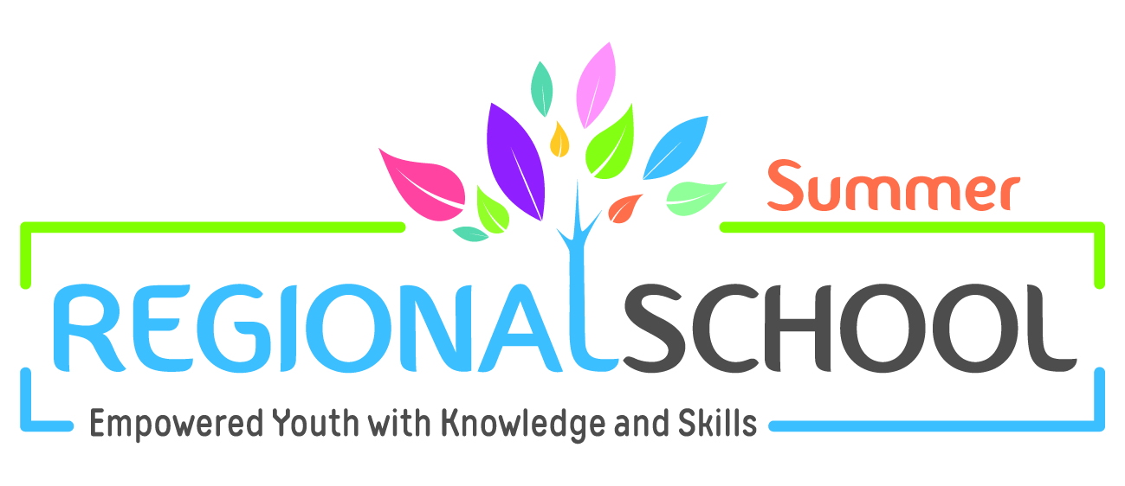

Call for Applications

Regional Summer School:
The End of MDGs – Beginning of SDGs
Achieving Gender- Just Sustainable Development?

14-18 August 2016 in Amman, Jordan

Heinrich Böll Foundation (hbs), represented through its offices in Palestine, Lebanon, Tunisia and Morocco, welcomes applicants from Arab countries in the Middle East and North Africa to apply for its Regional Summer School 2016 that will take place between 14-18 August 2016 in Amman, Jordan.

Heinrich Böll Foundation carries on these regional schools to build the capacities of the participants and to stir a debate about urgent current policy topics. They also provide the international lecturers with information about and viewpoints from the region, and offer an excellent platform for exchanging ideas, opinions, arguments and sharing experiences across the region. The program promotes networking among civil society actors, researchers, and activists in the region working in the fields of resource rights, governance, climate, gender and environment.

The focus of the Summer School of this year is Sustainable Development Goals (SDGs) and their approach to achieve gender- just sustainable development. Specific topics will be addressed related to gender and sustainability, inclusion of climate change and other environmental issues in SDGs, role of communities in resource management, gender integration to resource management and politics, and gender climate change adaptation.

We have chosen the SDGs to be the focus of Summer School 2016 in light of the current discussions on climate change politics and making environmental issues as specific goals in the SDGs, as an attempt to achieve sustainable development in all countries in the globe and not only in the “developing countries” as it was the focus of the Millennium Development Goals (MDGs).

Summer School 2016 will include lectures, working groups, round table discussions, workshops and others. In addition to the content-focused sessions, the Summer School will offer workshops for practical skill development in areas such as environmental campaigning and social media

Participants:

This Summer School inter alia addresses junior professionals, postgraduates, activists, and researchers working at NGOs, civil society organizations, think tanks or other institutions from Arab countries in the Middle East and North Africa. The age range is between 23 and 35 years.

Application Process:
To be considered for Summer School 2016, please fill out the application form (available at www.ps.boell.org, www.lb.boell.org, www.tn.boell.org, and ma.boell.org) and attach a Curriculum Vita as well as a short paper (2 pages maximum). The paper should focus on the topic of the Summer School and show the applicant’s knowledge as well as their ability to work independently and creatively. To this end, the applicant should choose a topic from within the subject area and point out its relevance to their local or national context, e.g. by introducing an exemplary project, a current debate etc. This could be written in a form of an essay or a short academic paper.

The Summer School will be conducted in Arabic and English. Good command of the English language is highly important since preparation material will be circulated before the Summer School, a large part of which will consist of English literature. The participants are therefore asked to indicate their English level in the application form.
Travel and accommodation costs of the participants will be covered by the Heinrich Böll Foundation.

Please submit your application documents via email.

Applicants from Morocco are asked to submit their application documents in English, Arabic, or French to:
Heinrich Böll Foundation Rabat, Ms. Zainab Elguerrab (ma-info@ma.boell.org)

Applicants from Tunisia, Algeria, Libya and Egypt are asked to submit their application documents in English, Arabic, or French to:
Heinrich Böll Foundation Tunis, Mr. Simon Ilse (info@tn.boell.org)

Applicants from Lebanon, Iraq, and Syria are asked to submit their application documents in English, Arabic or French to:
Heinrich Böll Foundation Beirut, Ms. Corinne Deek (Corinne.Deek@lb.boell.org)

Applicants from Palestine and Jordan are asked to submit their application documents in English or Arabic to:
Heinrich Böll Foundation Ramallah, Ms. Ronza Almadbooh (Ronza.Almadbooh@ps.boell.org)

Deadline for application is 30 April 2016.

